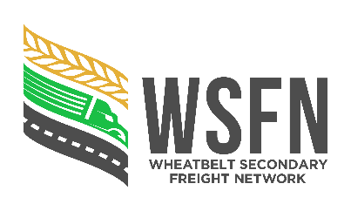 CERTIFICATE of COMPLETION

|  |
| --- |
| A separate certificate must be used for each Road Project |

(Please tick appropriate box)

|  |  |  |  |  |
| --- | --- | --- | --- | --- |
|  |  |  |  |  |
|  |  | Wheatbelt Secondary Freight Project |  |  |
|  |  |  |  |  |

|  |  |  |  |  |
| --- | --- | --- | --- | --- |
| **Project Details** | | | | |
|  |  | |  |  |
| Local Government: |  | | Financial Year: |  |
|  |  | |  |  |
| Road Name: |  | Route No: | Project No.: |  |
|  |  | |  |  |
| Description of completed works: |  | | Section (SLKs): | to |
|  |  | |  |  |

|  |  |  |  |  |  |  |  |  |  |  |  |  |  |
| --- | --- | --- | --- | --- | --- | --- | --- | --- | --- | --- | --- | --- | --- |
| **Approved Project Allocations** | | | | | |  | **Final Project Cost** | | | | | | |
| Total Project Allocation | Federal Contribution **(80%)** | | State Contribution **(13.333%)** | | LG Contribution **(6.667%)** |  | Final Total Project Cost | Federal Contribution  **(80%)** | | State Contribution  **(13.333%)** | | LG Contribution **(min 6.667%)** | |
| $ | $ | | $ | | $ |  | $ | $ | | $ | | $ | |
|  | |  | |  | |  |  | |  | |  | | |
| **Claimed State Contributions** | | | | | | | | | * Actual Federal and State Contribution cannot exceed the Approved Federal and State Contribution without an approved variation. | | | | |
| Claim No. 1 – **1st 40%** | | Claim No. 2 – **2nd 40%** | | Claim No. 3 – **Final Claim** | |  | **Total Funds Claimed** | | * If actual expenditure is within $1 000 of the Approved Project allocation, the full Approved Federal and State Contribution can be claimed (Road Project Grant only). | | | | |
| $ | | $ | | $ | |  | $ | |  | | | |  |

|  |  |  |  |  |  |  |
| --- | --- | --- | --- | --- | --- | --- |
| I certify that the works have been completed by the Council and that the total funds claimed for the project have been fully expended on this project. | | |  | I declare that the details provided within this Certificate of Completion are correct, that the Council has contributed a minimum of **6.667%** of the total project and acknowledge that Main Roads Western Australia can access the Council’s financial records to verify this claim. | | |
|  |  |  |  |  |  |  |
|  |  |  |  |  |  |  |
| Signature |  | Name |  | Signature |  | Name |
|  |  |  |  |  |  |  |
| **Works Supervisor/Engineer** |  | Date |  | **Chief Executive Officer** |  | Date |